
Karachi Institute of Economics and Technology

Course: Artificial Intelligence Program: Software Engineering
Faculty: Dr. Husain Parvez Class ID: 117183
Examination: Final Date: 12th June 2025
Total Marks: 100 Max. Time: 3 Hrs

- N-Gram Language Model (Apply) (CLO-3) (PLO-3) (15 Marks)

You are given the following small corpus of text:
"The cat sat on the mat. The cat ate the rat. The dog sat on the mat. The cat ran away. The dog ate the bone. The cat sat on the rug."

Build a trigram (3-gram) language model
Compute the trigram probabilities for all trigrams that occur at least once in the corpus.
Suppose a user has typed the first two words: "the cat".
List all possible next words (i.e., third words) that follow "the cat" in the corpus.
Compute the probability of each possible third word given the bigram ("the cat"). Report the probabilities.
Which word is most likely to come next after "the cat" according to your model? Show your computations

- The code given below is the GA algorithm to solve the 8-queen problem.
a) Explain the major components of the code? (Apply) (CLO-2) (PLO-2) (15 Marks)
b) How genetic algorithm avoids local minimum solution?
c) How would you modify the code to solve the TSP for 50 cities? No need to write the code. Just explain the changes through explanation, or write pseudoscope.
import random
import matplotlib.pyplot as plt
import numpy as np

# Genetic Algorithm Parameters
N = 8 # Number of queens
POPULATION_SIZE = 1000
MUTATION_RATE = 0.1
GENERATIONS = 1000

# Fitness function: Counts number of non-attacking queen pairs
def fitness(chromosome):
non_attacking = 0
for i in range(len(chromosome)):
for j in range(i + 1, len(chromosome)):
if chromosome[i] != chromosome[j] and abs(chromosome[i] - chromosome[j]) != abs(i - j):
non_attacking += 1
return non_attacking

# Create initial population of random chromosomes
def create_population():
return [random.sample(range(N), N) for _ in range(POPULATION_SIZE)]

# Select top 50% individuals based on fitness
def selection(population):
scores = [(fitness(ind), ind) for ind in population]
scores.sort(reverse=True)
return [ind for _, ind in scores[:POPULATION_SIZE // 2]]

# Crossover: combine parts of two parents to create a child
def crossover(parent1, parent2):
idx = random.randint(1, N - 2)
return parent1[:idx] + parent2[idx:]

# Mutation: randomly swap two positions
def mutate(chromosome):
if random.random() < MUTATION_RATE:
i, j = random.sample(range(N), 2)
chromosome[i], chromosome[j] = chromosome[j], chromosome[i]
return chromosome

# Main GA function
def genetic_algorithm():
population = create_population()
for generation in range(GENERATIONS):
population = selection(population)
new_population = population[:]
while len(new_population) < POPULATION_SIZE:
p1, p2 = random.sample(population, 2)
child = crossover(p1, p2)
child = mutate(child)
new_population.append(child)
population = new_population
best = max(population, key=fitness)
if fitness(best) == 28:
print(f"Solution found in generation {generation}")
return best
print(f"Best effort after max generations {generation}")
return max(population, key=fitness)

- Analyze the below given scenarios and suggest (i) What is the issue (Underfitting or Overfitting), and (ii) how the problem can resolved?
(Analyze) (CLO-3) (PLO-3) (15 Marks)

- You train a classification model, and it achieves 98% accuracy on the training set but only 67% accuracy on the test set.
- During training, your model’s accuracy quickly falls and never exceeds 60% on both training and validation sets, even after many epochs.
- You use a deep neural network with many layers on a small dataset (~500 samples). The training accuracy is very high, but the test performance is poor and highly variable.

- A researcher has developed a new machine learning model to predict the presence or absence of a
disease based on patient data. The researcher wants to evaluate the performance of the model
using various metrics. Which of the following evaluation criterias (given below) would be most
suitable for each of the below given scenarios?
(Apply) (CLO-3) (PLO-3) (15 Marks)
- The researcher wants to evaluate the model's ability to detect patients who actually have the disease.
- The researcher wants to evaluate the model's ability to avoid false alarms, i.e., predicting patients who don't have the disease.
- The researcher wants to evaluate the model's overall performance, including both true positives and true negatives.
- The researcher wants to evaluate the model's ability to predict patients who don't have the disease.
- The researcher wants to evaluate the model's ability to balance true positives and false positives.

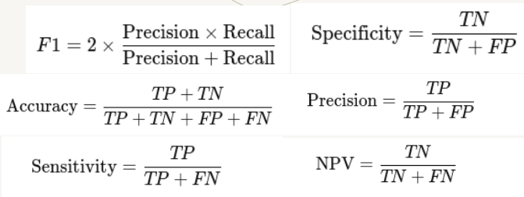

- A ice-cream distribution truck has to deliver ice-cream to 100 different locations in a single day. Design and implement a solution using Simulated Annealing to find the shortest possible circular route that starts and ends at the post office, visiting each location exactly once.

(Apply) (CLO-2) (PLO-2) (10 Marks)
a) Write the pseudo-code of the simulated annealing algorithm.
b) What is the role of the temperature parameter in Simulated Annealing?
c) Describe the acceptance probability formula used in Simulated Annealing.
d) Briefly describe the cost function that you will use in your algorithm?
e) How Simulated Annealing avoids a local minimum solution?

- Describe CSP.
(Understand) (CLO-1) (PLO-1) (15 Marks)
a) What are variables, domains and constraints in CSP?
b) How a constraint graph is a bi-partite graph? Can you give an example?
c) What are uniary, binary and high-order constraints? Give examples.
d) Why CSP solvers can often be faster than state-space search?
e) Explain the back-tracking algorithm to solve CSP?

- For a Vaccuum solving agent that can suck (S), turn-left (L), turn-right (R) in a 2 tiles room,
complete the below given state-space/solution-space. Draw the complete state-space.
(Understand) (CLO-1) (PLO-1) (15 Marks)

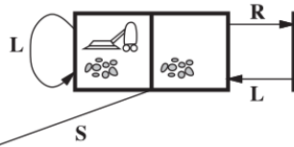

☺ Good Luck

